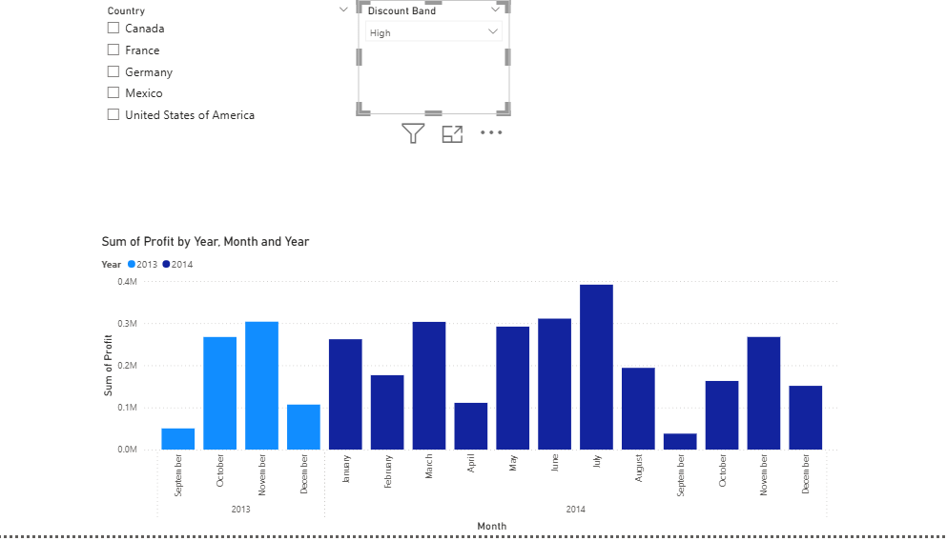

1. **CREATE a drop-down single SELECT SLICER FOR the DISCOUNT BAND.**

* GO TO VISUALIZATION PANE
* SELECT SLICER
* DRAG AND DROP THE FIELD DISCOUNT BAND INTO THE SLICER’S FIELD
* BY DEFAULT, THE SLICER WILL SHOW AS A LIST, SO TO CHANGE TO A DROP DOWN FORMAT, ON THE SLICER VISUAL, CLICK THE DOWN ARROW (IN THE TOP RIGHT CORNER OF THE SLICER).
* SELECT DROP DOWN.
* TO ENABLE SINGLE SELECT, SELECT THE SLICER VISUAL,GO TO FORMAT IN THE VISUALIZATION PANE, EXPAND SLICER SETTING.
* UNDER SELECTION CONTROLS, TURN SINGLE SELECT ON.

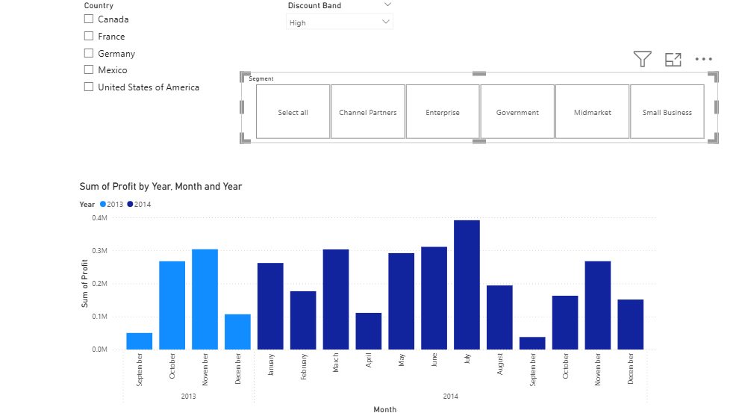

1. **CREATE TILE SLICER WITH SELECT ALL OPTION FOR SEGMENT.**

* **ADD A SLICER VISUAL**
* **DRAG THE SEGMENT FIELD INTO THE SLICER.**
* **TO CHANGE TO TILE STYLE, IN THE VISUALIZATION PANE, GO TO FORMAT**
* **UNDER SLICER SETTINGS🡪 OPTIONS CHANGE THE SLICER TO TILE LAYOUT.**

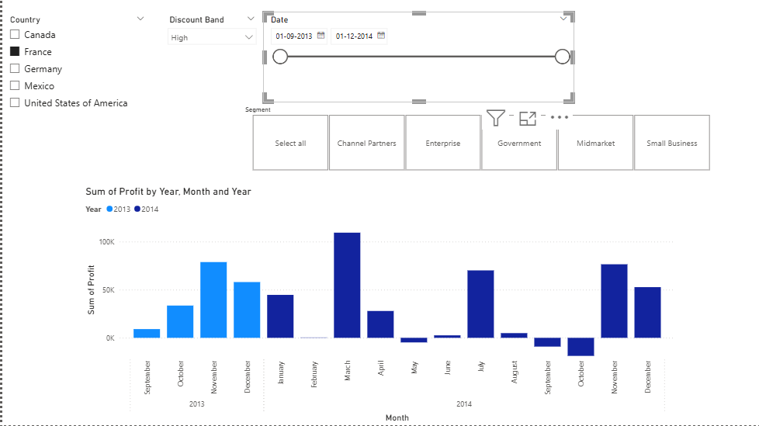

1. **CREATE A SLICER FOR DATE.**

* **ADD A SLICER VISUAL**
* **DRAG DATE FIELD INTO THE SLICER.**

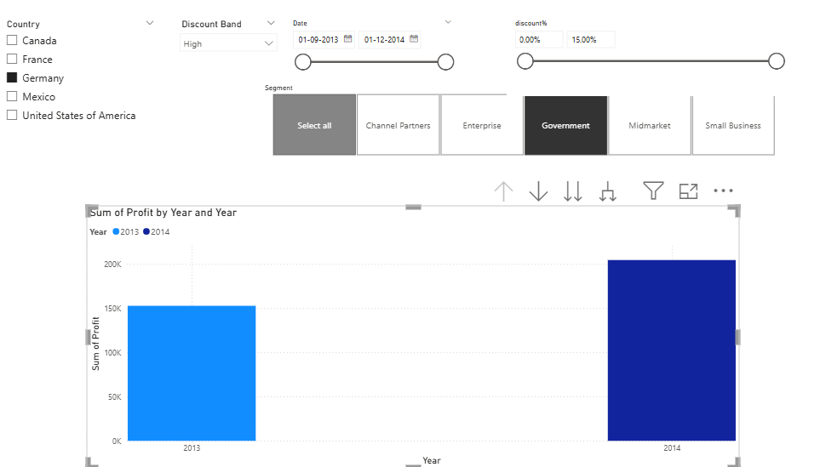

1. **CREATE A SLICER FOR THE DISCOUNT PERCENTAGE.**

* **ADD DISCOUNT PERCENTAGE COLUMN TO THE DATA.**
* **TO GET THE DISCOUNT PERCENTAGE VALUE, INSERT THE FORMULA [DISCOUNT% = FINANCIAL(DISCOUNT)/FINANACIAL(GROSS SALES)**
* **CHANGE THE VALUES INTO PERCENTAGE BY CLICKING ON THE % SYMBOL IN THE COLUMN TOOLS TAB.**
* **ADD THE SLICER VISUAL.**
* **DRAG AND DROP DISCOUNT PERCENTAGE.**

1. **WHAT IS THE PROFIT OF THE GERMAN GOVERNMENT IN THE YEAR 2014?**

* **SELECT COUNTRY FROM COUNTRY SLICER.**
* **SELECT ONLY THE GOVERNMENT OPTION IN SEGMENT SLICER.**
* **CLICK ON THE DRILL UP OPTION FOR THE YEAR.**